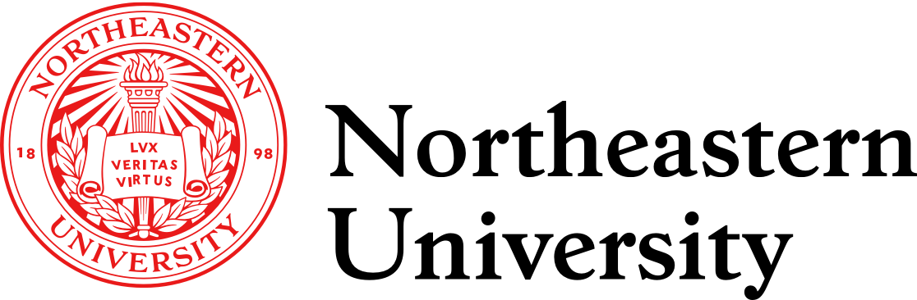

College of Professional Studies, Northeastern University
PJM 6015: PROJECT RISK MANAGEMENT
Instructor: Professor Kristen Drobnis

Group Assignment (GA) 1: Team Charter
Project Organization:
Team Member | Team Role
Ruisi Meng | Supporter
Mophy Sharma | Facilitator
Aastha Motwani | Supporter
Qingyu Sha | Recorder
Elizabeth Cohn | Project Manager

Group 4 Team Charter

Purpose of the Team
- Setting the benchmark for exceptional serviceability, dependability, and life change by building a trustworthy and respectful environment via teamwork, job ownership, time management, leadership, and communication skills.
- Use superior thinking to produce ideas and creativity that Reduce Risk changes in the project both functionally and attractively.
- Providing power solutions to achieve larger goals and cultivating the best collaboration culture for improved workplace management and environment.
- Through in-depth learning, we ensure the effective completion of the project and achievement in all critical areas.

Team Background and Contact Information
Name: | Ruisi Meng
Education: | Master’s degree in Human Resources management
Experience: | No experience
Organization: | ---------
Skills: | MS Office, MS Project
State (Time Zone): | EST
Contact Information: | Email: meng.ruis@northeastern.edu  Phone: 6179388654

Name: | Elizabeth Cohn
Education: | Undergraduate degree in International Relations and French
Experience: | 2 years of experience in 3 different hotels (Front Desk Agent/Supervisor, Sales Coordinator, Catering Sales Manager).  3 years of experience in the non-profit industry as an event planner.
Organization: | Atrium Hospitality, Massachusetts General Hospital Development Office
Skills: | Microsoft Project, full Microsoft suite and Mac equivalents, Hotel CRM systems
State (Time Zone): | EST
Contact Information: | Email : cohn.el@northeastern.edu  Phone : 2036964671

Name: | Mophy Sharma
Education: | Bachelor’s degree in Electronics and Communication Engineering, MBA and master's degree in Project Management
Experience: | 3 years of experience in operations and marketing
Organization: | Heidelburg cements, solar power nation and Ernst and Young
Skills: | MS Office, MS Project, Power BI,
State (Time Zone): | EST
Contact Information: | Email : sharma.mop@northeastern.edu  Phone : 8573282864

Name: | Qingyu Sha
Education: | Bachelor’s degree in Computer Science and master's degree in Finance Economics
Experience: | A few years in IT and eCommerce industries
Organization: | Microsoft, Adidas
Skills: | MS Office, MS Project, Python, R
State (Time Zone): | EST
Contact Information: | Email: sha.qi@northeastern.edu  Phone: 781-658-4945

Name: | Aastha Lalit Motwani
Education: | Bachelor’s degree in Electronics and Communication Engineering and master's degree in Project Management
Experience: | 10 Months in Automobile Industry
Organization: | M.G. Motor India Pvt Ltd
Skills: | MS Office, MS Project
State (Time Zone): | EST
Contact Information: | Email : motwani.a@northeastern.edu  Phone : 531-255-2239

Communication Tools and Techniques

Tools
- Teams
- Zoom
- Email
- WhatsApp
- Canvas Discussion Board

Techniques
- Weekly or Twice-Weekly Zoom Meetings to work collaboratively on assignments
- Feedback is provided on every work so that changes can be made easily
- Create an online document library to facilitate collaboration and discussion.
- Work logs are commonly used documents in the workplace and in your Co-op Work Terms to track what work is done, by whom, and how long it took.
- Teams could use Gantt Charts to help map out the work schedule clearly and in detail.

Membership Roles and Responsibilities

Project Manager
- Clarify the identified potential issues to the team members
- Resolve the conflicts among the team members
- Be the main contact person of the team to communicate with the instructor
- Develop, execute and monitor the team’s action plan to ensure the allocated tasks are completed on time
- Do final inspection and submit assignment on Canvas

Facilitator
- Organize and facilitate the meetings
- Creates and sends calendar invitation with Zoom information
- Support Project Leader to track the completion progress of the allocated tasks
- Create an open and safe atmosphere for idea sharing and lead a conversation to reach a consensus

Recorder
- Sets up the shared document in OneDrive folder for that week’s assignment
- Record the meeting minutes after the meetings and discussions.
- Archive all shared documents including individual and group assignments
- Inspect the completed group assignment with the facilitator to avoid spelling and grammar errors.

Supporters
- Support researching, editing etc.
- Assist Project Leader to do execution
- Provide extra assistance when required
- Provide insights and do research
- Help in conflict resolution
- Take up additional work when needed

Team Roles Rotation Schedules

Group 4 will rotate through the 4 roles in alphabetical order by last name in the order of Project Manager, Facilitator, Recorder and Support based on the below schedule.

 | Assignment 1 | Assignment 2 | Assignment 3 | Assignment 4 | Assignment 5 | Assignment 6
Elizabeth Cohn | Project Manager | Facilitator | Recorder | Support | Support | Project Manager
Ruisi Meng | Support | Project Manager | Facilitator | Recorder | Support | Support
Aastha Motwani | Support | Support | Project Manager | Facilitator | Recorder | Support
Qingyu Sha | Recorder | Support | Support | Project Manager | Facilitator | Recorder
Mophy Sharma | Facilitator | Recorder | Support | Support | Project Manager | Facilitator

Ground Rules

The establishment of ground rules within the team charter allows for increased accountability and transparency into the decision-making process, ground rules and will lead to improved acceptance and results for the final deliverables (Simmons, 2021).
- Team members will attend all pre-arranged Zoom and in-person meetings as scheduled to work on assignments outside of class.
- Whenever possible, team members will have their cameras on during Zoom Meetings to encourage participation and team building.
- Team Members will be always respectful of one another’s contributions and opinions through all methods of communication.
- To maintain a level of accountability amongst the team, Team Members will complete all tasks, deliverables and sub-deliverables as assigned by the set deadlines to meet the larger deadline of the project.
- Team Members will respond to messages promptly, within 24 hours to ensure the project continues to progress.
- Team Members are expected to attend group meetings prepared, having completed all required work ahead of time and being ready and willing to participate in discussions, including having read the assignment and done all necessary work prior to the first meeting of each assignment.

Decision Making Process

- When any team member feels something wrong, a proper way is to communicate with Project Manager.
- Project Manager gathers information from other team members before calling a meeting.
- In the situation that we confront a complex issue with several options, all team members examine the options, rank them in terms of risk and impact and then decide based on the agreed option.
- If the whole team cannot reach a consensus, we will apply ‘Voting’ to reach an agreement.
- Majority rules with all voting decisions. In the event, that a decision needs to be made with an even number of group members and there is a tie, the Project Manager breaks the tie.

Conflict Management Approach

Potential Conflicts
- Communication issues
- Task-based conflicts
- Leadership conflicts
- Personality clashes
- Personal Issues

Conflict Resolution
- Disputes over communication and differing viewpoints can lead to conflict. To avoid this, additional meetings should be scheduled, and differences between members of the team should be resolved promptly.
- To address task-based disagreements, each team member would've been allocated an equal number of tasks in advance. Furthermore, team members should clear any doubts as quickly as possible so that assignments are done ahead of schedule.
- Each member should be given equal opportunity, and the roles should be rotated proportionately.
- There'd be no two team members with the same personality. Differences in personality or perspective, on the other hand, should not disrupt the team's atmosphere, and conflict resolution should be emphasized.
- The work of a team member who is dealing with personal matters or is ill shall be allocated evenly among other team members based on their skill and availability.

Team Performance Assessment
Team Performance Assessment
Statement | Ranking (1 to 5)
Criteria for Team Performance Assessment are crucial to explore and integrate since they increase the possibility of accomplishing project objectives. Indicators that might be used to assess a team's effectiveness include:
· Clear grasp of the project's goals and expected outcomes | 5
· Timely submitted deliverables | 5
· Participated in all group meetings | 5
· Group members' contribution to weekly assignments | 5
· Group members' engagement during meetings | 5

Sign-Off Page

We, the signatories below, agree to the aforementioned rules and guidelines for the upcoming project.

Elizabeth Cohn

Elizabeth Cohn

Ruisi Meng

Ruisi Meng

Aastha Lalit Motwani

Aastha Lalit Motwani

Qingyu Sha

Qingyu Sha

Mophy Sharma

Mophy Sharma

References

Simmons, M. (2021, April 21). How to create a team charter (example included) - projectmanager.com. Retrieved April 14, 2022, from https://www.projectmanager.com/blog/how-to-create-a-team-charter

